L2 tests name: IT-Operation Management
Legal entities in scope: DBAG, ExR, EFAG, ECAG, CBF, CBL, LuxCSD, CI, CS and CFCL
IT Operations Management

[+ including AU-121-11-CSDR CSDR IT-Operation Management]

Test(s) according to RCA:

(TP1) Inquire with relevant personnel about the Group IT landscape and incidents monitoring process with the applications identified as relevant for the audit.
(TP2) Review Incident Management-related process documentation to validate whether it is in line with the DORA requirements (including timeliness and criticality).
(TP3) Inspect via representative sample the process of incident management and the reporting requirements set by DORA (e.g. with focus on the IT application identified as relevant for the audit – if not via other incidents which should be reported in line with DORA)
(TP4) Test the related Future Notes identified as relevant - FuN: 210817083234
(TP5) Inquire about the continuous monitoring of IT landscapes via Command Center Monitoring to validate that it is performed 24/7.
(TP6) Inspect a sample of weekly/monthly shift plans to validate that shifts are established for monitoring IT
(TP7) Inspect a sample of daily performed IT Operations Checklist to validate whether daily operation tasks were performed.

FuN: 210817083234
“During the 2021 SDLC audit it was noted that by design, maintenance jobs were established to be executed directly in production. Meaning after an update to the jobs, no tests in a dedicated test environment were performed. Following the blocking rule incident that occurred on June 2021 due to a bug within a weekly Account Master (AM) maintenance job, one of the Long-Term Measures (LTMs) defined in the PILS was to “review the cleaning jobs maintenance definition”. This review was being performed by Corporate IT during the SDLC audit fieldwork.
In the next IT Operation Management audit, review and evaluate the design and management of maintenance jobs.”
FuN related LEs: DBAG, ECAG, CBF, CBL, CFCL

Audit procedures/source:
- Information directly requested from auditee (via e-mail or call) or extracted from provided documentation during preparation phase.

Conclusion:
Ok, no exception identified

Internal audit (VS, YW) has performed the following Audit procedures:

-------------------------------------------------------
Summary of work done:
-------------------------------------------------------

AP | Work done | Result
TP1 | Based on the initial application mapping according to the AAP 2025 Golden Source, the following applications including sample CSDR applications were identified to be part of the scope for this audit:  IA conducted walkthrough meetings with Xetra/Eurex Infrastructure Operations and Trading IT Support teams on 25 Feb 2025. IA also conducted walkthrough meetings with PaaS Storage & Backup and PTIT PaaS Delivery teams on 26 Feb 2025. During the discussions, IA understood the following:  Xetra/Eurex Infrastructure Operations & Trading IT Support:  During the discussions, IA understood that applications handled by Xetra/Eurex Infrastructure Operations & Trading IT Support follow the Trading IT Incident Management Procedure_2024 1.pdf which describes the detailed handling of IT Incidents within the operational and customer focusing units of the department Derivatives & Cash Trading IT in alignment with the central IT Incident Management Process. The Incident Monitoring aspects for these applications follow the standard timely handling and resolution of incidents recorded within SAP CRM7 tool’s Operational Level Agreements:  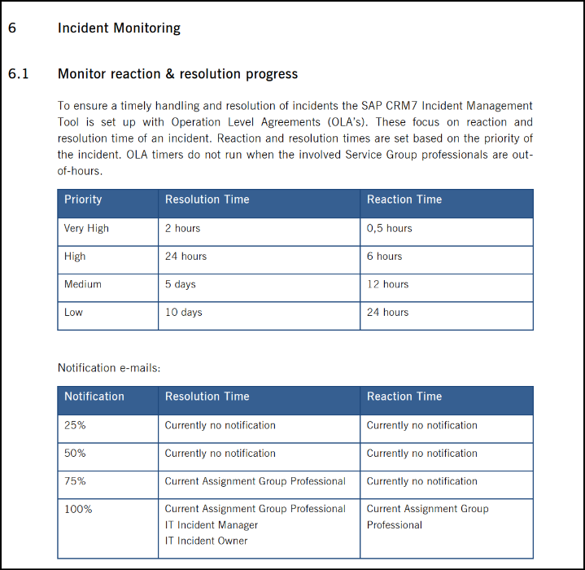  IA further understood that a central reporting for proper tracking and reporting of IT Incidents per Product Line & Assignment Group is available on IT Incidents for Line Management within the SAP Analytics Cloud (SAC) tool.  PaaS Storage & Backup and PTIT PaaS Delivery:  During the discussions, similar to the above, IA understood that applications handled by PaaS Storage & Backup and PTIT PaaS Delivery also follow the central IT Incident Management Process defined by the IT Governance, Risk and Transformation (Dpt). Section 3 of this document clearly defines that CRM7 is used across DBAG as the centralized incident database for creating and tracking anomalies/incidents during the incident management process. An anomaly/ incident which impacts DBAG either as owning (in terms of operating / servicing) or using function needs to be recorded within CRM7. The incident database serves both as a source for incident-relevant information as well as for the check of the repetitiveness criterion.  In addition to the above, IA performed a walkthrough with Monitoring & Application Support (S) on 26 February 2025. Based on the walkthrough and review of the IT Operations Management (Clearstream) Process document, IA understood that the Command Center Application Monitoring (U) based out of Luxembourg is responsible for ensuring the controlled monitoring of the central hardware configuration and production software, and the efficient handling of system events in such a way that IT services can be delivered in accordance with the Service Level Agreements/Service Definition Statements. Refer to TP5, TP6 and TP7 on activities performed by Command Centre Monitoring team.  Communication with PTIT PaaS Delivery  All product lines/teams within DBG follow the centralized Incident Management-related process documentation.   ICT Incident Management Procedure.pdf  ICT Incident Emergency Procedure_v 2.9_DORA-published.pdf   Template Incident Statement v1.9 after DORA RTS JULY 24 adjusted.docx  Communication with IT Core Process Design & Operations  It must be noted that IA provides general assurance through sampling of CSD-R relevant applications AID860, AID587 that they follow the same processes. No exception was noted. | OK, no exceptions noted.
  AID | Application Name | Application Owner | Section/Unit Responsible
  AID2037 | XEOPs Cockpit Manager | Thomas Reich | Xetra/Eurex Infrastructure Operations & Trading IT Support
  AID2039 | XEOPs SAN RM | Thomas Reich | Xetra/Eurex Infrastructure Operations & Trading IT Support
  AID2119 | XEOPS Storage Operation | Thomas Reich | Xetra/Eurex Infrastructure Operations & Trading IT Support
  AID716 | EMC CTA | Bénédicte Clotuche | PaaS Storage & Backup
  AID937 | Brocade SAN | Bénédicte Clotuche | PaaS Storage & Backup
  AID938 | EMC Storage | Bénédicte Clotuche | PaaS Storage & Backup
  AID940 | NetApp Storage | Bénédicte Clotuche | PaaS Storage & Backup
  AID941 | Storage support tools | Bénédicte Clotuche | PaaS Storage & Backup
  AID587 | LDMS | Steffen Thomas Gremm | PTIT PaaS Delivery
  AID860 | TARGET Services GUI Access | Steffen Thomas Gremm | PTIT PaaS Delivery
TP2 | IA discussed with IT Core Process Design & Operations (U) on 26 February 2025 and understood that the Incident Management-related process documentation was updated to reflect the DORA requirements including timeliness and criticality.  The RTS requirements laid out by DORA regarding the time limits for the initial notification and intermediate report and final reports as referred to in Article 19(4)(a) to (c) of Regulation (EU)2022/2554 shall be as follows:  a) the initial report shall be submitted as early as possible within 4 hours from the moment of classification of the incident as major, but no later than 24 hours from the moment the financial entity has become aware of the incident.  b) An intermediate report shall be submitted the latest within 72 hours from the submission of the initial notification even where the status or the handling of the incident have not changed as referred to in Article 19(4)(b) of Regulation (EU) 2022/2554. Financial entities shall submit without undue delay an updated intermediate report, in any case, when regular activities have been recovered.  c) the final report shall be submitted no later than one month from the submission of the latest updated intermediate report.  Section 5.5.2 of the ICT Incident Management Procedure.pdf document clearly lays out the notification and reporting requirements to the regulator containing incident-related information:  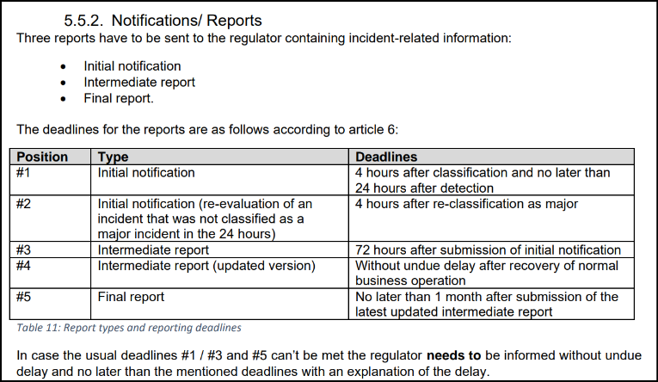  In addition to this, the document lays out the criticality classification process pertaining to incidents. Specifically, section 5.3.2 Incident Classification states that all DORA-relevant data must be gathered throughout the Incident Classification Meeting and documented. The documentation must be transferred into the Incident Statement Template (see chapter 7.4 Supporting Documents) which can be performed following the meeting or crisis. Incident Statements for major ICT-related incidents must be stored for at least two years on the designated central provisioned location.  The criteria to be evaluated are:  - Clients, financial counterparts, and transactions  - Reputational impact  - Geographical spread  - Data loss  - Duration and service downtime  - Economic damage.  The thresholds for each criterion which must be used as reference points or at least minimum criteria for the assessment of an incident is provided below. The baseline for each threshold should be defined and updated on a regular basis by each legal entity.  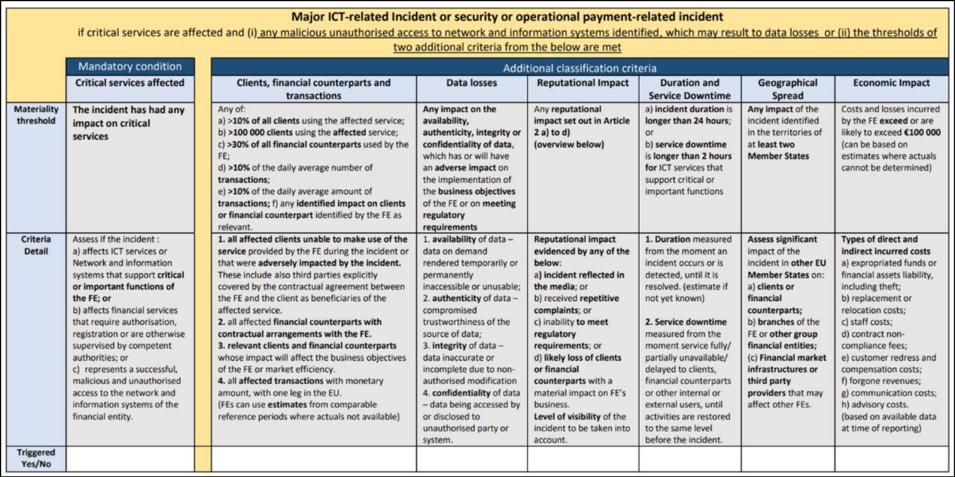  The guidelines for internal severity criteria which exemplifies the alert levels, incident/crisis classification, and the impact are given below:  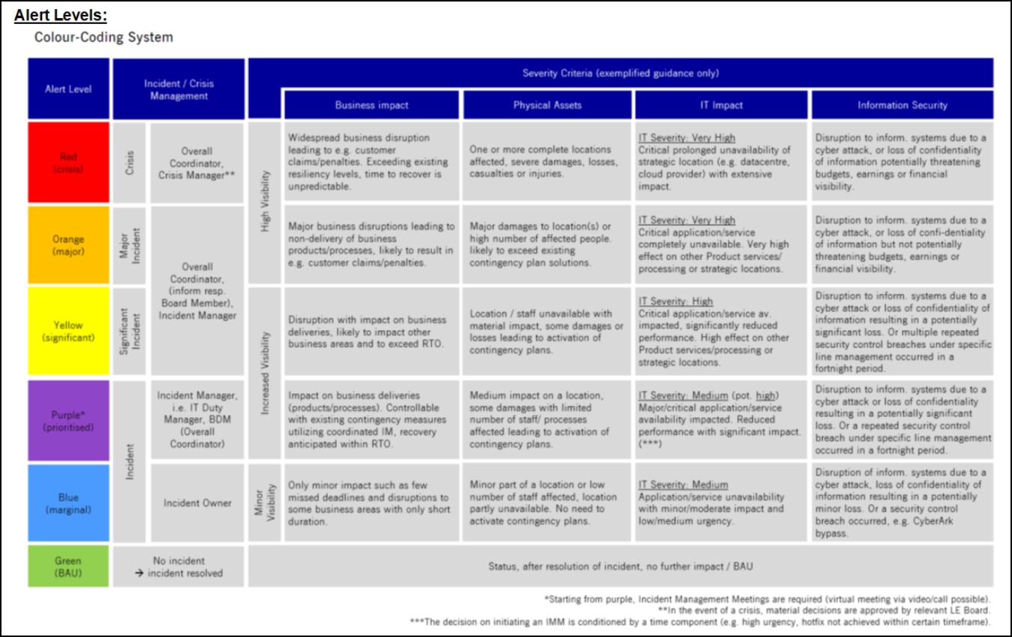 | OK, no exceptions noted.
TP3 | Section 5.3 Incident Classification of the ICT Incident Management Procedure.pdf document provides a detailed overview of how incidents are classified in accordance with the regulatory requirements of DORA.  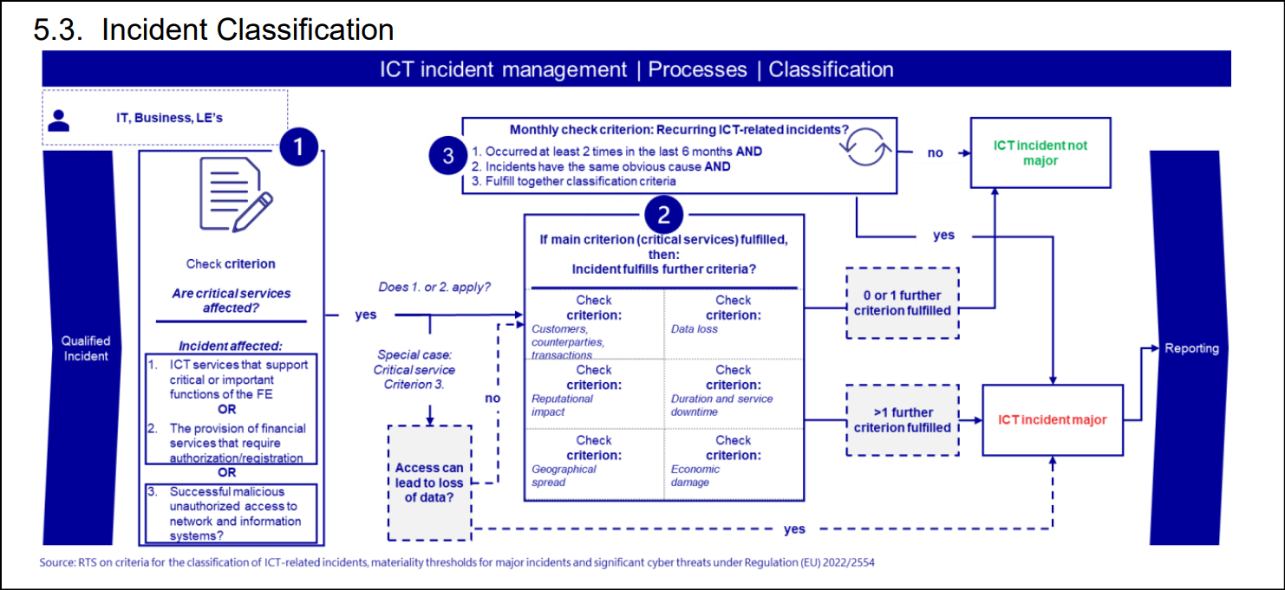  Upon review of the snapshot above, IA understood that a preliminary criterion checks in performed to assess whether an incident has affected any of the following:  - ICT service that supports CIF  - Provision of financial services that required authorization/registration  - Successful malicious unauthorized access to network and information systems  Basis the answers to these checks, it is further to be assessed whether the effect of the incident on the following criteria and their defined thresholds:  - Clients, financial counterparts, and transactions  - Reputational impact  - Geographical spread  - Data loss  - Duration and service downtime  - Economic damage.  In case the incident affects two out of the six criteria mentioned above, it is classified as a “ICT incident – major” which attracts the reporting requirements including timeliness/notifications.  The DORA regulation is application as of 17 January 2025. Considering the audit period ends as of 31 December 2024, the audit team decided to consider a sample of incidents that occurred after the effective date of the DORA regulation and identified the following incidents that occurred after the DORA effective date:  - S/4HANA reaching memory limit – Incident date 21 January 2025  - Eurex T7 Partition 8 & 10 unavailability – Incident date 03 February 2025  - TS - T2S Incident – Incident date 27 February 2025:  S/4HANA reaching memory limit incident:  SAP S/4 HANA system's memory was fully utilized due to Group report jobs consuming substantial amounts of memory. This caused an out-of-memory situation, impacting jobs and operations with errors related to memory allocation, leading to overall system performance degradation. The incident was resolved by canceling the Group report jobs, which freed up memory and returned the system to normal. The system was monitored for a couple of hours to ensure stability.  IA reviewed the incident statement and understood that S/4HANA application was considered CIF relevant. Accordingly, the criteria check against the six parameters mentioned above was performed. IA further noted that no thresholds as defined by DORA were breached. Furthermore, the DBAG internal alert level for this incident was categorized as “Blue”, meaning this had only minor impact on business, physical assets, IT and information security. Appropriate course of actions was taken to resolve the incident including escalation to IT Duty Manager, initiating incident chat, analysis by support team, identification of root-cause and resolution.  No reporting under DORA requirements was required to be triggered as it was classified as “ICT incident non-major”.  24012025_S4 Hana reaching memory limit.pdf – Incident Management Statement  S4HANA Incident_Incident Ticket.pdf  S4HANA Incident_Problem Ticket.pdf  PilsWeb9535.pdf – Production Issue Log  IT_ICM_Standard_Protocol_v1.0 1.pdf – Incident Classification Meeting protocol  FW_ Incident detected_ _BLUE_ _SAP S_4 HANA not available_.msg – IA communication  Eurex T7 Partition 8 & 10 unavailability Incident:  On February 3rd, 2025, at about 11:00 CET, the Eurex T7 PATE primary process in Partition 7, including three products with options on EureStoxx50, EuroStoxx50 EOD and FTSE 100, crashed and triggered a failover to the secondary PATE Process. Between 16:00 CET and 16:30 CET, the same event occurred in Partition 8 (428 products), 9 (295 products) and 10 (186 products), where the secondary PATE process took over as designed. Thereafter, for two out of twelve partitions of the Eurex T7 trading system also the secondary PATE process failed resulting in unavailability for trading due to a T7 application software error on those partitions. Eurex T7 Partition 8 became unavailable at 17:18 CET and Eurex T7 Partition 10 became unavailable at 17:24 CET shortly before the scheduled close of continuous trading for most products on these two Eurex T7 Partitions.  IA reviewed the incident statement and understood that T7 application was considered CIF relevant. Accordingly, the criteria check against the six parameters mentioned above was performed. IA further noted that two out of the six criteria thresholds as defined by DORA were breached namely Clients, financial counterparts and transactions and Geographical Spread. Furthermore, the DBAG internal alert level for this incident was categorized as “Purple”, meaning this had medium impact (potential high impact) on business, physical assets, IT and information security. IA reviewed the incident management statement and noted that a detailed root-cause analysis was performed, and appropriate course of actions was taken to resolve the issue including rollback of the software fix from Jan 31st, 2025, in the planned timeframe. It was identified that the incident was related to the change T7-562665 which was installed on 31 January 2025 and hence, the rollback was performed.  Accordingly, reporting under DORA requirements was required to be triggered as it was classified as “ICT incident - major”. See below notification requirements vis-à-vis the actual communication regarding this incident:  Incident trigger date and time: 03 February, 2025, 17:24 CET  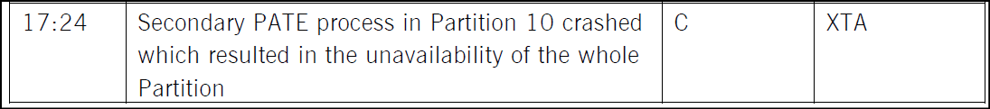  20250203_Eurex T7 Partition 8 & 10 unavailability_Incident Statement_not distributed.pdf – Incident Management Statement  T7 Partition Unavailability Incident_Incident Ticket.pdf  T7 Partition Unavailability Incident_Problem Ticket.pdf  Initiale Meldung IKT-Vorfall - Eurex Frankfurt AG - 03.02.2025.msg – Initial notification  Initiale Meldung IKT-Vorfall - Eurex Frankfurt AG - 03.02.2025 - Passwort.msg – Initial notification password  RE Zwischenbericht IKT-Vorfall - Eurex Frankfurt AG - 03.02.2025.msg – Intermediate report  Zwischenbericht IKT-Vorfall - Eurex Frankfurt AG - 03.02.2025 - Passwort.msg – Intermediate report password  Abschlussbericht IKT-Vorfall - Eurex Frankfurt AG - 03.02.2025.msg – Final report  Abschlussbericht IKT-Vorfall - Eurex Frankfurt AG - 03.02.2025 Passwort.msg – Final report password  TS - T2S Incident:  On 27 February 2025, IA was informed that T2S is currently facing an incident impacting Application-to-Application (A2A) outbound and inbound communication and T2 is facing an incident impacting processing of the Application-to-Application (A2A) transactions and User-to-Application (U2A) access. The incident management has classified the incidents as ‘yellow. Later, IMM summary from BDM IMMs indicates downgrade from Yellow to Purple to Blue.  On 5 March, IA discussed with Clearstream colleagues - Stephane Deschamps, Damian O'Connell, Laurent Kaiser, Didier Lenges, Nathalie Rouilleaux, Nathalie Adam, Lisa Holland on proper documented risk assessment of the incident, incident classification levels - as this has had adverse international media outlets with Clearstream explicitly named over multiple days, Regulatory Communication, communication to DBG Board level and Internal Minutes (link to email comms). At the time of audit fieldwork, it was noted that the incident was handled as per DBG process, Incident remediation measures were ongoing, and the Incident Management Statement would be published/circulated in next days. Problem Report is linked here. Key takeaway from the meeting:  - This is not considered an IT incident because it had “only business impact”  - It was only classified as yellow, therefore not reported to DBG Board (to be involved from orange and above)  - It was communicated to Compliance and CISOs of the affected LEs.  - It was not reported under DORA as T2 and T2S were explicitly excluded from DORA. IA checked the exact exemption. Ok.  - It was however reported to regulators under the CSDR requirements.  - Near miss – actual impact was limited as Clearstream was able to catch up with the backlog overnight and only delayed opening on the next morning by 20 minutes.  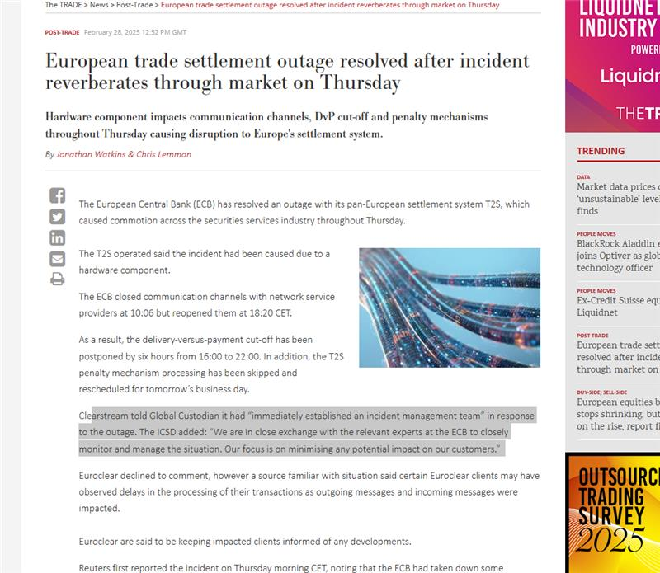  T2: Incident and cut-off extension  T2S: Settlement feed interrupted - Update  T2S: Settlement feed interrupted  For hint: IA Internal communication  => OK | OK, no exceptions noted.
  Type | Actual Communication Time | Deadline met?
  Initial notification | 03 February 2025, 21:09 | Yes, within 4 hours after identifying as major
  Intermediate report | 06 February 2025, 19:04 | Yes, within 72 hours after submission of initial notification
  Intermediate report (updated version) | 07 February 2025, 17:09 | Yes, no undue delay noted
  Final report | 25 February 2025, 18:07 | Yes, within 1 month after submission of updated intermediate report
TP4 | FuN: 210817083234 – This FuN entry pertains to the application Account Master (AM – AID031). This application does not pertain to any of the L2s reviewed within the scope of 2025-001 IT Operation Management audit. Furthermore, according to the AAP 2025 GS, this application has been mapped to the L2 AU-001-02-Clearstream Customer maintenance including technical maintenance under L1 001-Customer Onboarding and Maintenance.  Considering the above, the FuN entry has been re-assigned to the L1 001-Customer Onboarding and Maintenance for further review.  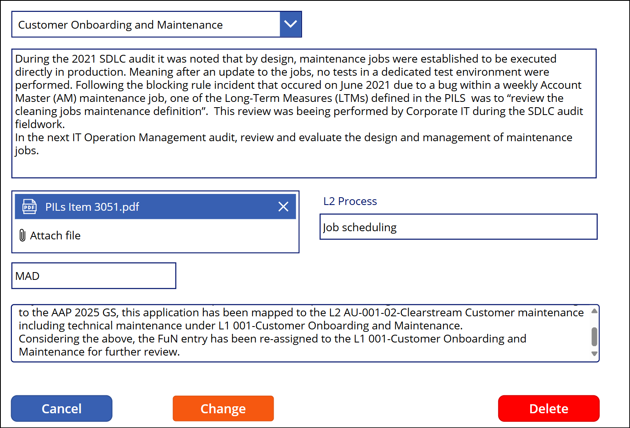 | Not applicable. FuN reassigned to another audit.
TP5 | IA performed a walkthrough with Monitoring & Application Support (S) on 26 February 2025. Based on the walkthrough and review of the IT Operations Management (Clearstream) Process document, IA understood that the Command Center Application Monitoring (U) based out of Luxembourg is responsible for ensuring the controlled monitoring of the central hardware configuration and production software, and the efficient handling of system events in such a way that IT services can be delivered in accordance with the Service Level Agreements/Service Definition Statements.  During the walkthrough, IA understood that the following processes are monitored continuously, i.e., 24/7:  - IT Operations Management (Clearstream) process  - Network Monitoring  - Clearstream Applications and Batch Monitoring  - Mainframe Monitoring  - Frankfurt-based Applications and Batch Monitoring  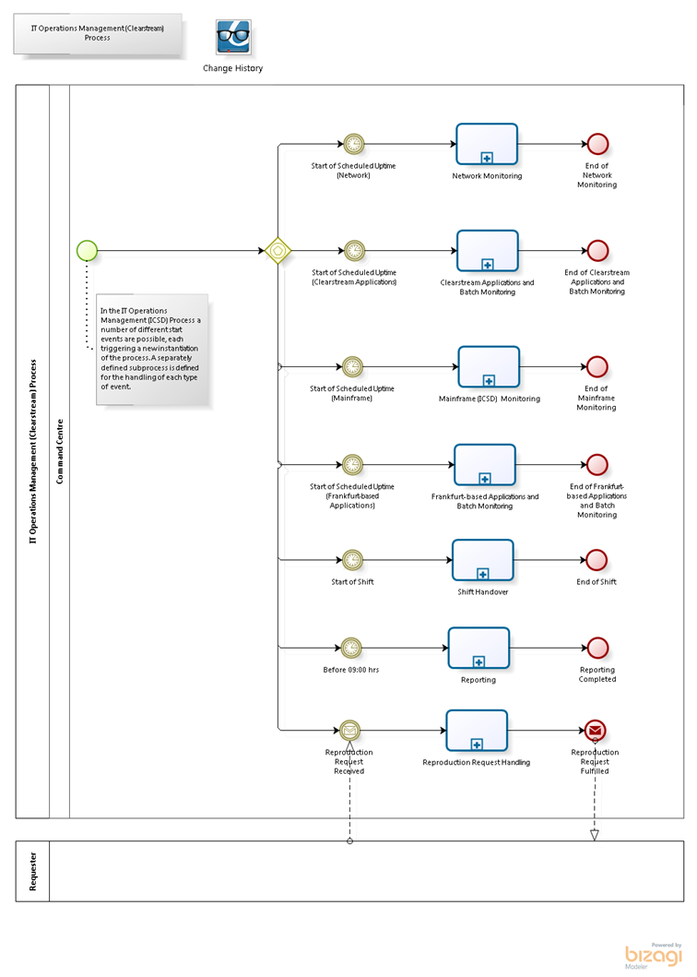  Appropriate KPIs, Risks, Controls, Roles and Responsibilities (RACI+S Matrix), Input and Output requirements have been established clearly within the IT Operations Management (Clearstream) Process document.  The Daily Production Reports capture the details of KPIs monitored daily to assess delays vis-à-vis deadlines and how they are documented. For a sample of 25 random days, IA reviewed the existence of Daily Production Reports to confirm whether continuous monitoring was in place and if KPIs were consistently monitored. Based on the review, IA confirmed that continuous monitoring was in place and the reports were prepared consistently to capture the required KPIs.  IT Operations Management (Clearstream) Process document.  Daily Production Reports | OK, no exceptions noted.
TP6 | During the walkthrough discussions with the Monitoring & Application Support team, IA understood that shifts are organized in advance and planned for the full year at the beginning of each year. This ensures that required coverage is properly organized and that all people/staff are aware of the shift plans and can get organized accordingly.  To confirm this, IA reviewed the shift plans for 2024 and 2025 and noted that monthly shift plans take into account allocation of day and night shifts, possible sicknesses, mandatory holidays, work from home and office days and other scenarios for all monitoring individuals within the Monitoring and Application Support section segregated into teams for the ease of day-to-day operations.  At the end of each shift, a Shift Handover Report is prepared and sign-off by individuals responsible for both the previous shift and the current shift.  In addition to this, Daily Checkpoints are created to record the details of events and tasks pertaining to the continuous monitoring performed by the Monitoring and Application Support team. Please refer to TP6 below for spot checks on the Daily Checkpoints.  IOM Shift Plans 2024.xlsx  IOM Shift Plans 2025.xlsx  Communication with Monitoring & Application Support (S) | OK, no exceptions noted.
TP7 | During the walkthrough discussions held with Monitoring and Application Support team, IA understood that the team does not work on checklists but against timelines and deviations if any (as all monitoring is automated. The Command Centre Monitoring personnel do not do any stop/start of applications/services manually. They check the monitors and the alerts that are raised in real-time based on scheduling activities and unexpected events that are raised via the monitoring tools. Such unexpected events are recorded within the Checkpoints summary document daily.  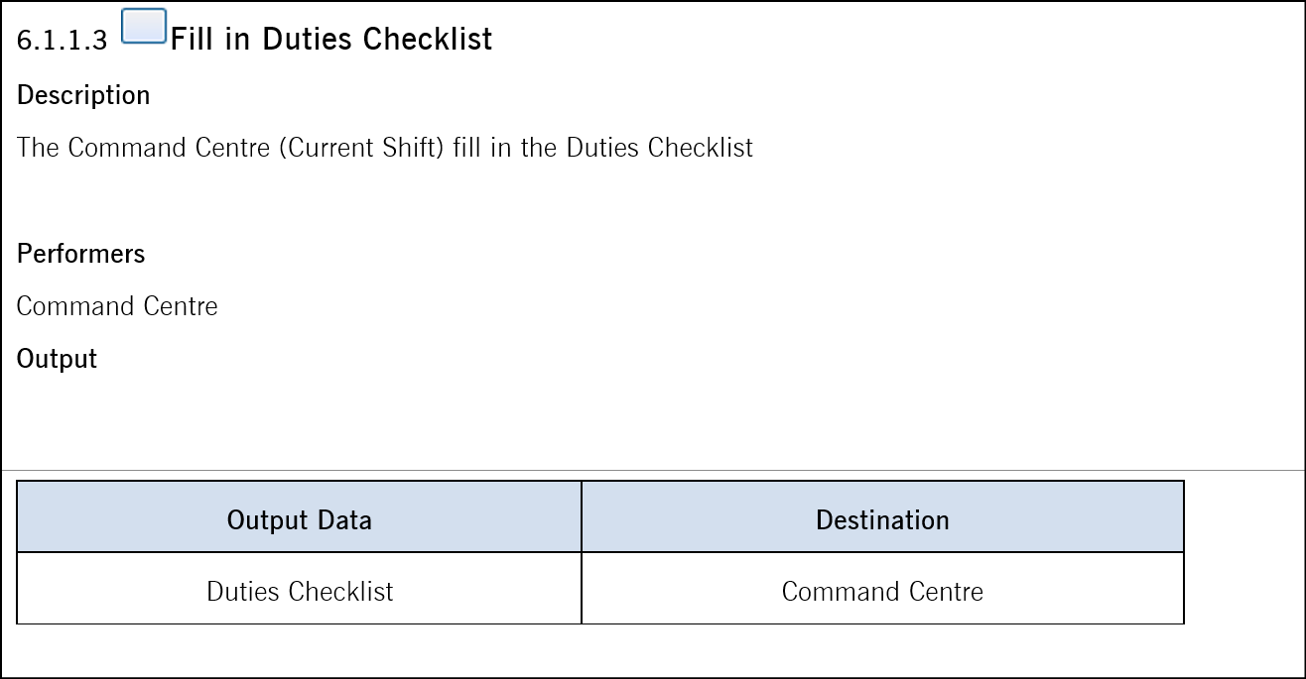  To validate the existence of the Checkpoints summary documents, IA selected 12 random days (1 for each calendar month in 2024) and reviewed the Checkpoint documents. Based on the review, IA confirmed that Checkpoint documents were clearly summarized with the unexpected events that are raised via the monitoring tools daily. Furthermore, IA reviewed the sample Checkpoint documents and confirmed that a daily check was performed to evaluate whether Incident Tickets been created for every production Abends or delays that was reported in Checkpoint-DB.  I have put one example of a checkpoint/checklist document for Frankfurt as well as an example of a production KPI report that is filled daily to document and assess delays vs deadlines and how they are documented.  Checkpoint documents  Communication with the Monitoring & Application Support (S) | OK, no exceptions noted.

Caveat: All notes in this document do not represent a protocolary transcript or quotations of the meetings. They rather provide an overview over the content of the meeting. Further the notes may be arranged according to the topics discussed and not based on the chronological course of the meeting.

